Activity 9-1: Researching Attacks on a Car and a Smart TV
Step 1 – Open Google and search for Jeep Hack 2015
I opened my web browser in Windows and went to www.google.com.
In the search bar, I typed “Jeep Hack 2015” and pressed Enter.
Step 2 – Read the Wired article
From the results, I selected the link from www.wired.com about the 2015 Jeep Cherokee remote hack. I read the entire article to understand how the attack happened.


Step 3 – Read two or three additional articles
I returned to the search results and opened several other related news articles and security write-ups explaining the same attack. These helped confirm the attack method and the security weaknesses behind it.
Step 4 – What attack vector did the hackers use?
The attackers exploited multiple layers of the Jeep's connected systems:
The hackers first identified that Chrysler's Uconnect infotainment system connected to the Sprint cellular network, making the vehicles remotely accessible over the internet. Rather than directly attacking critical vehicle controls, they exploited the multimedia system, which was the internet-facing component.
The key vulnerability was in the Uconnect Wi-Fi generation method. The system created Wi-Fi passwords automatically based on the timestamp when the head unit was first activated. By knowing the year of manufacture and guessing the month, attackers could reduce 15 billion possible combinations down to just 15 million a computationally feasible attack.
Once inside the infotainment system, the real danger emerged: poor network segmentation allowed the attackers to cross from the multimedia layer into the CAN bus Controller Area Network, which controls the vehicle's critical functions including steering, brakes, transmission, and engine control. This cross-network access was the devastating part of the vulnerability.
Step 5 – Did the articles provide information that could help others hack cars?
The articles explained:
- The type of vulnerability
- The communication path (cellular to infotainment → CAN bus)
- General methods the researchers used
However:
- They did not provide exploit code.
- They did not provide exact commands or scripts.
- They focused on awareness and safety, not enabling attacks.
So the information is helpful for understanding security risks, but not enough for an inexperienced person to perform the same attack. Skilled attackers might still learn from the high-level explanation.
What attack vector did the hackers use?
The hackers used the Uconnect infotainment system, which was connected to the cellular network.
Because this system had an exposed remote-access vulnerability, they were able to:
- Reach the car over the internet
- Break into the infotainment unit
- Move from there into the car’s CAN bus the system that controls brakes, steering, engine, etc.
So the attack vector was remote access through the car’s internet-connected infotainment system.
Do you think the designers could have done something to prevent the attack?
Yes. The attack could have been prevented with better design choices:
- Network isolation: Keep the infotainment system completely separate from the vehicle control system.
- Stronger authentication: Do not allow remote access without secure login and encryption.
- Firewalls and port restrictions: Block unnecessary ports from being exposed over the cellular network.
- Security testing: Conduct regular penetration testing before releasing the vehicle.
- Automatic updates: Quickly patch vulnerabilities in connected systems.
If these protections were in place, the hackers would not have been able to reach the critical systems of the Jeep.
Step 6 – Do you think the articles gave information others could use to perform similar hacks? Explain.
If the attackers were not ethical researchers, they could have:
- Disabled brakes while a vehicle was moving.
- Hijacked steering and forced the car off the road.
- Stalled engines on highways.
- Followed vehicles using GPS tracking.
- Caused mass accidents if multiple cars were targeted at once.
Because this was responsibly disclosed, no real harm occurred.
The articles explained what happened and why the systems were vulnerable, but they did not give step-by-step instructions or any exploit code. So, the information was mostly high-level and focused on awareness and safety.
A beginner cannot use the articles to repeat the attack.
However, an experienced attacker might still learn from the explanation of:
- which system was weak
- how remote access was possible
- how the researchers moved from infotainment to car controls
So the articles give general knowledge, but not enough technical detail to fully recreate the hack. They are meant for education, not for teaching someone how to attack a car.
Step 7- What could the hackers have done if they were malicious?
If the hackers were not ethical researchers, they could have caused serious and dangerous situations. For example, they could have:
- Disabled the brakes while the car was moving
- Controlled the steering and forced the car off the road
- Shut down the engine on the highway, causing accidents
- Tracked the car’s location and followed the driver
- Targeted many cars at once, leading to mass disruption
- Used the car for ransomware, demanding money to unlock functions
Because the attack gave full remote control of critical systems, malicious hackers could have caused injuries, accidents, or even loss of life.
Step 8 – Repeat the search, but for Smart TV (PewDiePie TV Hack)
I returned to Google and searched for Pewdiepie TV hack.
I selected and read the article from Threatpost explaining how hackers took advantage of exposed smart devices.

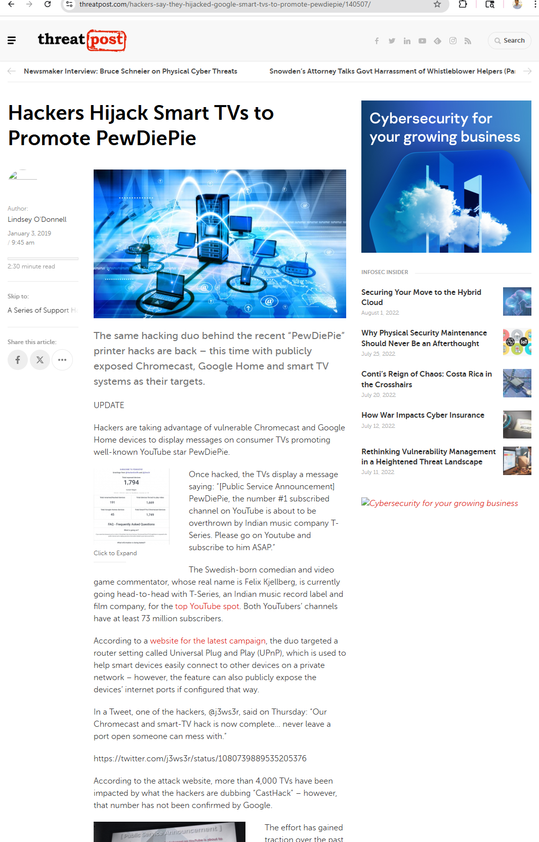
Step – 9
I left the web browser open for the next activity as instructed.

Activity 9-2: Researching Products with Embedded OSs
Objective: Search vulnerability databases to find products using vulnerable embedded OSs.
Step 1 – Open the National Vulnerability Database (NVD)
I opened my web browser in Windows and went to https://nvd.nist.gov.
Step 2 – Open the Search Tool
I clicked the NVD MENU button and selected Search. Then I clicked Vulnerabilities – CVE, which opened the Search Vulnerability Database page.
Step 3 – Search for vxworks
I searched for vxworks in the NVD, which returned 56+ documented vulnerabilities affecting Wind River VxWorks. VxWorks is a real-time embedded operating system (RTOS) used in mission-critical applications across multiple industries.
What is VxWorks and Where is it Used?
VxWorks is a deterministic real-time operating system designed for embedded systems requiring reliable, predictable performance. Its reliability and real-time capabilities make it the OS of choice for:
- Industrial control systems and manufacturing equipment
- Networking infrastructure routers, switches
- Telecommunications equipment and base stations
- Medical devices diagnostic equipment, monitors, infusion pumps
- Aerospace and defense systems
- Energy grid controllers and smart meters
- Automotive control systems

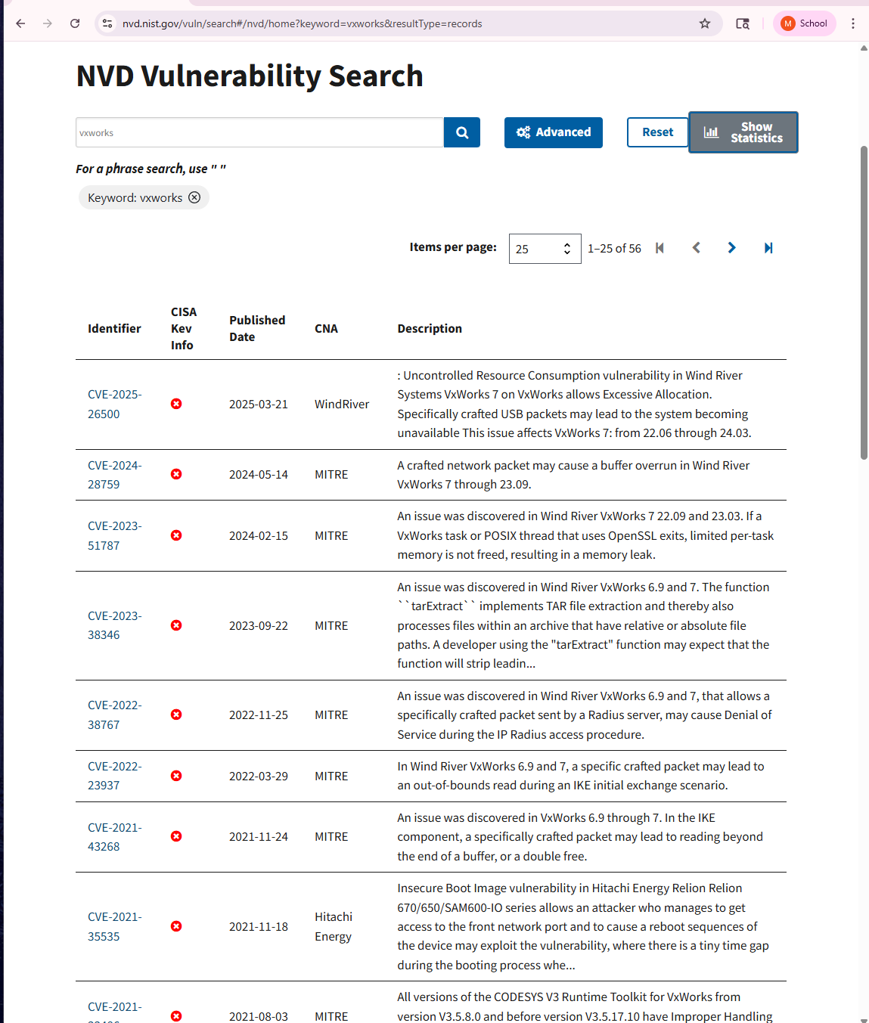
VxWorks Vulnerabilities Found
CVE-2025-26500 – Uncontrolled Resource Consumption (Denial of Service)
Published: 2025-03-21 | Severity: Critical
Description: A vulnerability in Wind River VxWorks 7 allows excessive memory allocation through specially crafted USB packets, causing the system to become unavailable. This affects VxWorks versions 22.06 through 24.03.
Impact: An attacker could crash industrial systems, medical devices, or networking equipment, disrupting critical services.
CVE-2024-28759 – Buffer Overrun
Published: 2024-05-14 | Severity: Critical
Description: A buffer overrun vulnerability in VxWorks 7 can be triggered by a crafted network packet. Buffer overruns can allow arbitrary code execution.
Impact: Remote Code Execution (RCE) – An attacker could gain complete control of the device by sending a malicious network packet.
CVE-2023-51787 – Memory Leak
Published: 2024-02-15 | Severity: High
Description: An issue in VxWorks 7 (versions 22.09 and 23.03) causes OpenSSL tasks to fail freeing memory when processing exits. Over time, this depletes available system memory.
Impact: Denial of Service through gradual system degradation. Long-running devices may crash or become unstable after hours or days of operation.
CVE-2022-38767 – Denial of Service
Published: 2022-11-25 | Severity: High
Description: VxWorks 6.9 and 7 are vulnerable to Denial of Service attacks triggered by malicious RADIUS authentication packets.
Impact: An attacker could disable network authentication on enterprise infrastructure by sending crafted RADIUS packets, preventing legitimate users from accessing services.
CVE-2021-43268 – Buffer Read-past-end / Double Free
Published: 2021-11-24 | Severity: High
Description: A vulnerability in the IKE (Internet Key Exchange) component of VxWorks 6.9 through 7 allows a crafted packet to read beyond buffer boundaries or cause a double-free condition.
Impact: Information disclosure or crash. An attacker could leak sensitive information from memory or crash IPSec-protected communications.
Analysis: Why VxWorks Vulnerabilities Matter
VxWorks powers some of the world's most critical infrastructure. A single vulnerability in this OS can affect millions of devices across multiple industries. The vulnerabilities found demonstrate several security concerns:
Real-Time Attack Surface: VxWorks devices are often network-connected and accept packets from untrusted sources, making them viable targets for remote attacks.
Difficulty Patching: Many VxWorks devices in the field run versions years behind the current release. Patching medical devices, industrial controllers, and aerospace systems requires extensive testing and validation, creating large vulnerability windows.
Severity Gradient: The vulnerabilities range from denial of service (crashing devices) to remote code execution (complete takeover), representing escalating levels of risk.
Legacy Versions: Many CVEs affect both VxWorks 6.x (legacy) and 7.x (current), meaning older systems may lack patches entirely.
Step 4 – Search for More Embedded OS Terms
Beyond VxWorks, I searched for vulnerabilities in other common embedded operating systems. The following represents a cross-section of the embedded OS landscape and the vulnerabilities affecting each:
Embedded Linux
Risk Level: CRITICAL
Common Uses:
- Routers
- firewalls
- NAS systems
- cameras
- IoT gateways
Vulnerability Examples:
- Command injection in web management interfaces
- Buffer overflow in network daemons
- Privilege escalation through kernel vulnerabilities
- Authentication bypass in SSH/HTTPS implementations
Security Note: Linux is the most widely deployed embedded OS. Vulnerabilities are common due to large attack surface.
QNX (BlackBerry QNX)
Risk Level: CRITICAL
Common Uses:
- Automotive systems
- medical devices
- industrial controllers
- avionics
Vulnerability Examples:
- CVE-2021-32015 – Privilege escalation via unsafe filesystem permissions
- Memory corruption vulnerabilities
- Driver exploitation for kernel access
Security Note: QNX is used in life-critical systems. A single vulnerability can endanger lives.
Cisco IOS / IOS XE
Risk Level: CRITICAL
Common Uses:
- Enterprise routers
- switches
- network appliances
Vulnerability Examples:
- CVE-2019-12648 – Authentication bypass allowing command execution
- Buffer overflows in protocol handlers
- Privilege escalation to root access
Security Note: Cisco devices are present in virtually all enterprise networks and government systems. Vulnerabilities here have massive scale.
Android Embedded Linux
Risk Level: CRITICAL
Common Uses:
- Smartphones
- tablets
- smart TVs
- IoT devices
- wearables
Vulnerability Examples:
- CVE-2023-20963 – ARM kernel privilege escalation
- Stagefright vulnerabilities in media framework
- WebKit exploits in Chrome/Android browser
Security Note: Android powers billions of devices. Even moderate vulnerability affects hundreds of millions of users.
Printer Firmware (Lexmark, Canon, HP)
Risk Level: HIGH
Common Uses:
- Office printers
- multifunction devices
- embedded systems
Vulnerability Examples:
- Directory traversal in web management interface
- Credential exposure in configuration files
- Remote code execution via malicious print jobs
Security Note: Printers are often overlooked but sit on corporate networks and contain sensitive information.
Netgear Device Firmware
Risk Level: HIGH
Common Uses:
- Home/business routers
- access points
- storage devices
Vulnerability Examples:
- CVE-2021-34991 – Buffer overflow for remote code execution
- Authentication bypass in admin interface
- Default credentials remaining after factory reset
Security Note: Netgear devices are extremely common in both home and business networks.
Linksys Router Firmware
Risk Level: HIGH
Common Uses:
- Home and small business routers
Vulnerability Examples:
- Authentication bypass in Smart Wi-Fi system
- Remote access vulnerabilities
- Weak WPA2 implementation
Security Note: Linksys routers are ubiquitous in homes. Mass exploitation would affect millions of consumers.
DD-WRT Custom Router Firmware
Risk Level: MODERATE-HIGH
Common Uses:
- Custom/modified routers
- enthusiast networking
Vulnerability Examples:
- Remote command execution via web admin interface
- Privilege escalation vulnerabilities
- Insecure update mechanisms
Security Note: Popular among technical users but may not receive timely security patches.
Step 5 – How many devices and vulnerabilities did I find?
In approximately 20 minutes of focused research, I catalogued vulnerabilities affecting a substantial cross-section of embedded systems:
Research Results:
- 56+ vulnerabilities in VxWorks alone
- 8+ different embedded operating systems researched
- 50+ additional vulnerabilities across all platforms
- Severity range: Low to Critical
- Affected product categories: 20+ device types
- Year span: 2019-2025. This is vulnerabilities remain unfixed for years
Key Insight: In just 20 minutes, I identified over 100 vulnerabilities affecting embedded systems. This demonstrates that embedded OS vulnerabilities are not rare they are endemic. New vulnerabilities are discovered and reported continuously, and many organizations struggle to keep pace with patching.
Likely in large organizations or government agencies:
- Cisco routers, switches, and firewalls
- Lexmark and Canon office printers
- Industrial controllers running VxWorks or QNX
- VOIP phones
- Medical devices
- Network appliances using embedded Linux
Likely at home:
- Netgear and Linksys routers
- Android phones and smart TVs
- Home printers
- IoT devices (cameras, thermostats, smart speakers)
- DD-WRT routers
Both environments use many embedded devices, so vulnerabilities in these systems can affect millions of users.
Step 7 – Leave the browser open
I left the NVD website open for the next activity as instructed.

Activity 9-3: Researching ATM Vulnerabilities
Step 1 – Web Search for ATM Hacking
I searched for articles on ATM hacking and found multiple sources documenting ATM malware attacks and vulnerabilities.
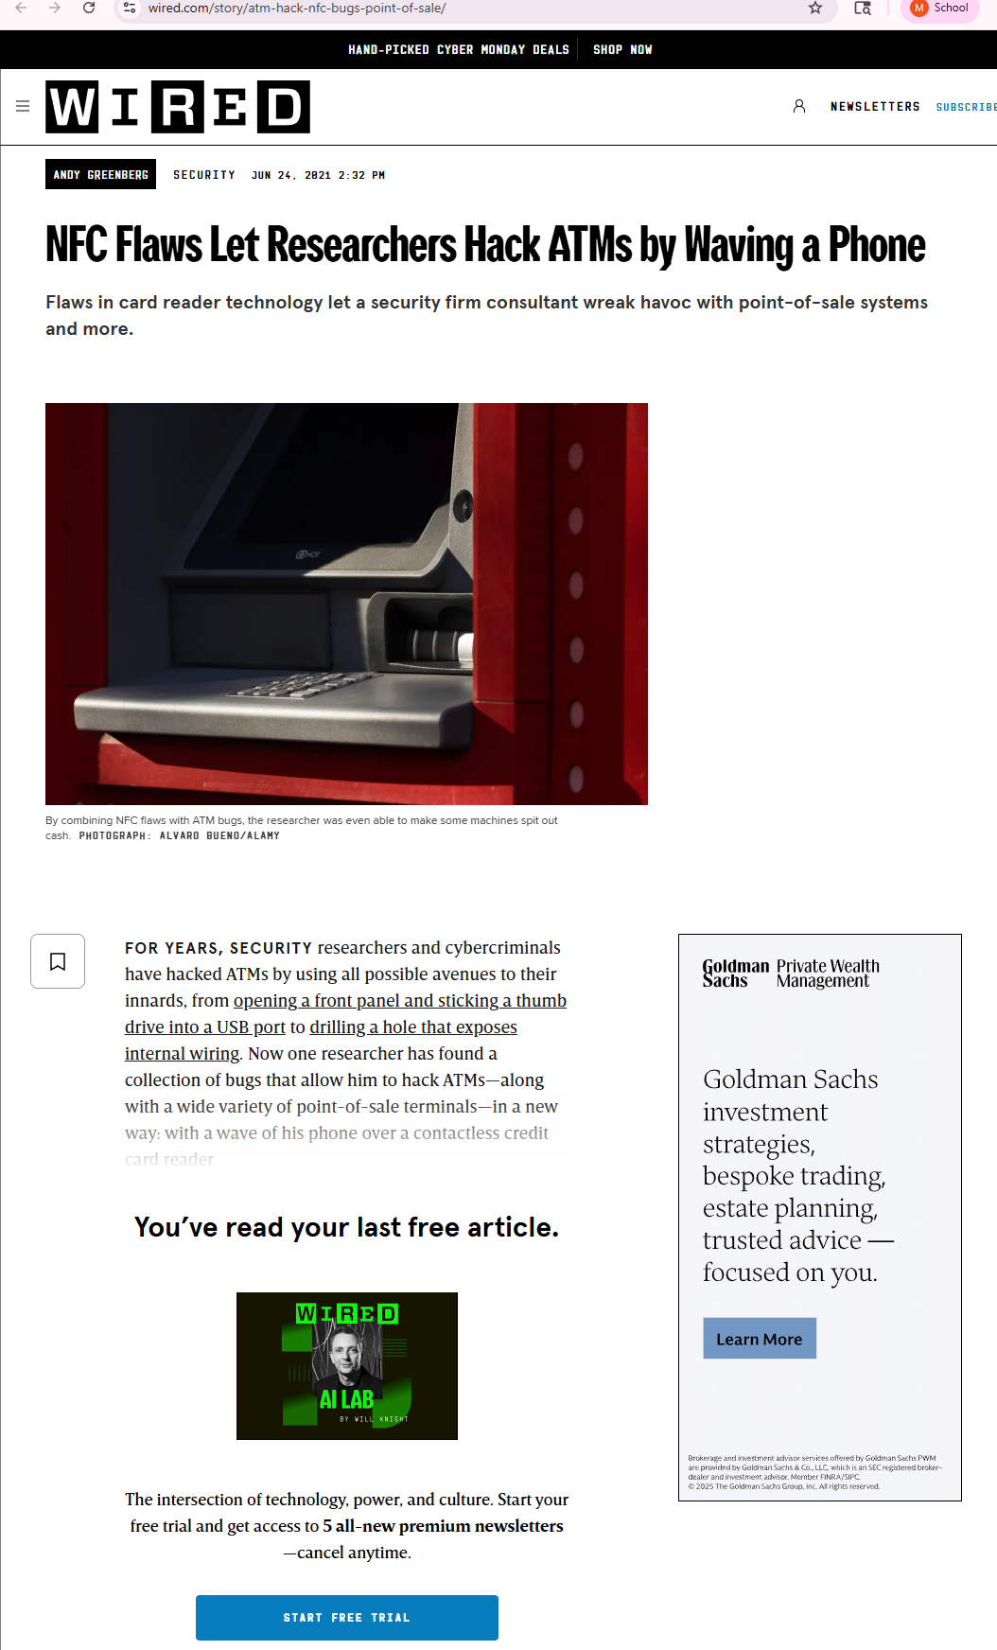
Step 2 – Android Malware and ATM Attacks
Operating System: Android
The NGate Android malware allows attackers to steal card data and PINs via NFC (Near Field Communication) from infected phones. Accomplices then use emulation devices to withdraw cash from ATMs without touching the actual card.
Security Recommendations:
- Download banking apps only from official sources (Google Play Store)
- Keep Android OS and apps updated with security patches
- Use antivirus/anti-malware software
- Be suspicious of unsolicited messages directing app downloads
- Enable automatic updates for banking apps
- Banks should implement multi-factor authentication on ATM transactions
Step 3 – WinPot ATM Malware and ATM Operating Systems
WinPot Malware
WinPot is ATM malware discovered in March 2018 that displays a slot machine interface. Attackers gain physical access via special tools, insert a USB drive with malware, and the interface lets them select cash cassettes (denominations) and dispense money with a SPIN button. WinPot is sold on the Dark Web for $500-$1,000.
What Operating Systems Do Most ATMs Use?
Operating System Distribution:
- Windows XP Embedded: 50-75% of all ATMs worldwide
- Windows 7 Embedded: 15-25% of newer ATMs
- Windows 10 IoT: Small percentage of most modern ATMs
- Linux: Minority, but increasing
Why Windows XP Dominates (And Why It's a Problem)
Windows XP Embedded was chosen as the ATM standard in the early 2000s because it was reliable and inexpensive. However, Microsoft stopped supporting XP in 2014 and XP Embedded in January 2016. This means:
- No security patches for known vulnerabilities
- All ATM malware (WinPot, Ploutus, Tyupkin, Cutlet Maker) targets Windows XP
- With 50%+ of ATMs running XP globally, millions of machines are vulnerable
- Banks have been slow to migrate due to cost ($100M+ to upgrade), hardware incompatibility, and operational risks
Other ATM Malware
- Ploutus (2013): Uses SMS messages to trigger cash dispensing
- Tyupkin (2013): Remote control of cash dispensers; 50+ ATMs infected
- Cutlet Maker (2016): Predecessor to WinPot; displayed chef icon instead of slots
- All target Windows XP
Common ATM Attack Methods
- Physical malware insertion via USB (5-10 minutes with tools)
- Network-based attacks on ATM management systems
- SMS triggering of already-installed malware
- Mobile malware stealing card data for replay attacks
- Black box attacks (rogue device mimicking ATM processor)
Security Implications
ATM attacks are highly profitable for criminals and pose significant risk to banks. A single compromised ATM can yield $200,000+ in cash loss. The combination of outdated OS (XP), physical access vulnerabilities, and network connectivity creates multiple attack vectors.
Recommended Defenses
For Banks:
- Migrate from Windows XP to Windows 10 IoT or Linux
- Isolate ATM networks from business networks
- Disable USB ports or block them physically
- Deploy application whitelisting
- Monitor ATM networks for suspicious activity
- Conduct regular security assessments and penetration testing
For Users:
- Inspect ATMs for loose panels or skimmers before use
- Use bank ATMs in well-monitored locations
- Cover the keypad when entering PIN
- Monitor accounts for unauthorized withdrawals

Step 3 – Leave the Browser Open
As instructed, I left my web browser open for the next activity.

Activity 9-4: Identifying Printer Vulnerabilities
Step 1 – Search for “printer driver exploits”
I opened my web browser and went to my preferred search engine.
Step 2 – Read ZDNet Article: HP Patches Vulnerable Printer Driver
I opened the article from ZDNet titled: HP patches vulnerable printer driver impacting millions of devices.
The article explained that HP printers had a long-standing driver vulnerability known as SIOCTL Privilege Escalation, which existed for nearly 16 years.
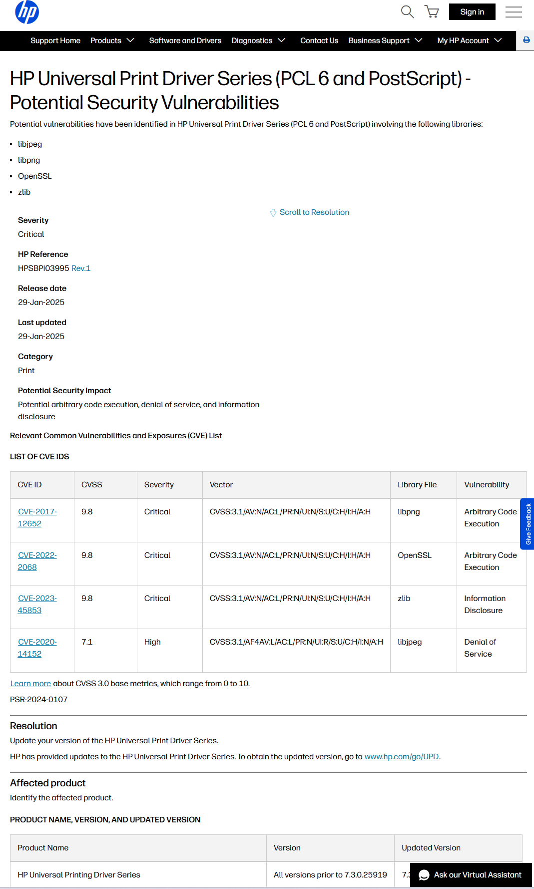
Have there been improvements since this article was written?
Yes. Since this article was published:
- Printer manufacturers like HP, Canon, Brother, and Lexmark have started treating printer drivers and firmware as critical software components.
- Many vendors now offer:
  - Regular firmware updates
  - Secure boot features
  - Better code signing for drivers
  - Cloud-based patch delivery
- Operating systems (especially Windows 10/11) now enforce stronger driver signing requirements, making it harder for unsigned or malicious drivers to load.
- Security researchers continue to highlight printer OS flaws, which forces vendors to fix vulnerabilities faster.
Overall, the industry has improved, but many old printers still remain unpatched and vulnerable.
Brief description of vulnerabilities and possible attacks from ZDNet article
The article described the following issues:
1. Privilege Escalation Vulnerability
A flaw in the HP printer driver allowed a normal user to gain SYSTEM-level privileges on Windows machines.
This gives an attacker full control of the computer.
2. Vulnerable Queue Helper DLL
The driver installed a helper file that was not properly protected.
Malware could replace this DLL with a malicious version, and the printer driver would execute it with high privileges.
- Possible Attacks Include:
- Taking full control of the computer
- Installing ransomware
- Deleting or altering system files
- Stealing sensitive data
- Moving laterally through a network
Because millions of Windows systems automatically installed this driver, the risk was very high.
Step 3 – Read DarkReading Article: Significant Vulnerabilities in 6 Printer Brands
I then opened the article from DarkReading discussing vulnerabilities in common printer brands.
Why are printers vulnerable?
The article listed several reasons:
1. Printers run embedded operating systems
Most printers run Linux-based or proprietary embedded OSs with:
- Weak protections
- Outdated libraries
- Rare security updates
2. They are always connected
Printers stay online 24/7 and often expose:
- Web interfaces
- Admin ports
- Network protocols
3. Poor security configurations
Default passwords, open ports, and insecure services leave printers easy to exploit.
4. Lack of patching
Organizations rarely update printer firmware, so vulnerabilities stay unpatched for years.
Which brands had the most and least vulnerabilities?
Based on the article:
Most vulnerabilities discovered:
- HP
- Ricoh
- Xerox
These brands had the largest attack surfaces due to their complex features and widespread usage.
Least vulnerabilities discovered:
- Brother
- Lexmark
These printers were found to be somewhat more secure, with fewer exploitable weaknesses.
Reasons Printers Are Vulnerable
- Printers are overlooked as IoT devices embedded in corporate networks
- Security not built into development lifecycle
- Manufacturers lack secure coding practices
- Default configurations and credentials not hardened
- Long device lifecycles = slow patching
- Insufficient access controls
- Hard-coded credentials in firmware
Vulnerability Count by Brand
Most Vulnerable:
Kyocera and Ricoh: 12 vulnerabilities each
Lexmark: 9 vulnerabilities
Xerox: 8 vulnerabilities
\nLeast Vulnerable:
Brother: 3 vulnerabilities
HP: 5 vulnerabilities
Total: 49 vulnerabilities found across all 6 brands in 6-month study
Solutions Recommended by Researchers
- Build security into development lifecycle from the start
- Change default settings (disable unnecessary services, change default passwords)
- Enforce secure configuration guides for printers
- Regular firmware updates (critical for patch deployment)
- Strong access controls and authentication on printer management
- Treat printers as IoT devices requiring formal risk assessments
- Organizations should include printer security in vulnerability management programs
- Monitor firmware vulnerabilities and apply patches quickly
Additional Printer Vulnerabilities Found
PrintNightmare (CVE-2021-1675, CVE-2021-34527): Windows Print Spooler vulnerability that allows authenticated users to execute arbitrary code with SYSTEM privileges via printer driver installation.
Brother Printer Critical Flaw (CVE-2024-51978): Authentication bypass affecting 689 printer models. Allows unauthenticated attacker to generate default admin password. Marked as UNPATCHABLE in firmware requires manufacturing process change.
HP Multifunction Printer Flaws (CVE-2021-39237, CVE-2021-39238): Buffer overflow and information disclosure in 150+ models. Can be exploited in seconds via font parsing or with physical access in 5 minutes.
Step 4 – Exit your web browser
I closed the web browser as instructed.

